Student worksheet

3.1 Energy can be transferred

Pages 40–43 and 168

Energy transfers

1 What is an energy transfer?

2 What is the main source of energy on the Earth?

3 In the following diagram you can see the transfer of energy from one object to another.

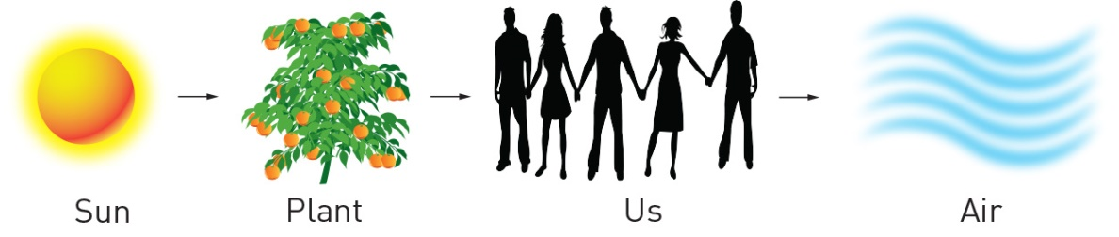

What is the name given to the transfer of energy from:

a the Sun to plants?

b plants to humans?

4 Draw a flowchart, similar to the diagrams on pages 40–43, for the transfer of

a the Sun’s energy to an iPhone

b chemical energy in coal to a toaster

c tidal energy (which generates electricity using a turbine) to a television

d chemical energy (battery) to a car radio

e the Sun’s energy to a person bouncing a basketball

Extend your understanding

5 Match each type of energy with its meaning.

|  |  |  |
| --- | --- | --- |
| Energy |  | Meaning |
| 1 Electrical |  | A Stored energy – any object above the ground has this |
| 2 Chemical |  | B Heat energy |
| 3 Sound |  | C Energy of movement |
| 4 Thermal |  | D Energy stored in chemical bonds |
| 5 Potential |  | E Caused by the vibration of particles |
| 6 Kinetic |  | F Energy of electronic change |

6 There is one key type of energy missing from question 5. What is it?

7 For each of the pictures below, label the type of energy present:

|  |  |  |  |
| --- | --- | --- | --- |
| SW0302_00951 | SW0303_00951 | SW0304_00951 | SW0305_00951 |
| SW0306_00951 | SW0307_00951 | SW0308_00951 | SW0309_00951 |
| SW0310_00951 | SW0311_00951 | SW0312_00951 | SW0313_00951 |

Student worksheet

3.2 Potential energy is stored energy

Pages 44–45 and 170

Potential energy is stored energy

1 What is potential energy?

2 What are the four types of potential energy? Give an example of each.

3 In the following table, identify the type of potential energy shown in each picture.

|  |  |  |  |  |
| --- | --- | --- | --- | --- |
| SW0617_01361 |  | SW0618_01361-rm |  | SW0619_01361-rm |
| SW0620_01361-rm |  | SW0621_01361-r |  | SW0622_01361-r |
| SW0623_01361-r |  | SW0624_01361-r |  | SW0612_01361-r |

4 Name two objects that have potential chemical energy transformed into another type of energy. For each object, state the type resulting energy.

5 Name two objects that have potential elastic energy transformed into another type of energy For each object, state the type resulting energy.

6 Name two objects that have potential gravitational energy transformed into another type of energy. For each object, state the type resulting energy.

Extend your understanding

7 Potential energy is used in children’s playgrounds. Choose five pieces of play equipment shown in the diagram below. For each item selected, name the type of potential energy it uses and explain how this results in motion.

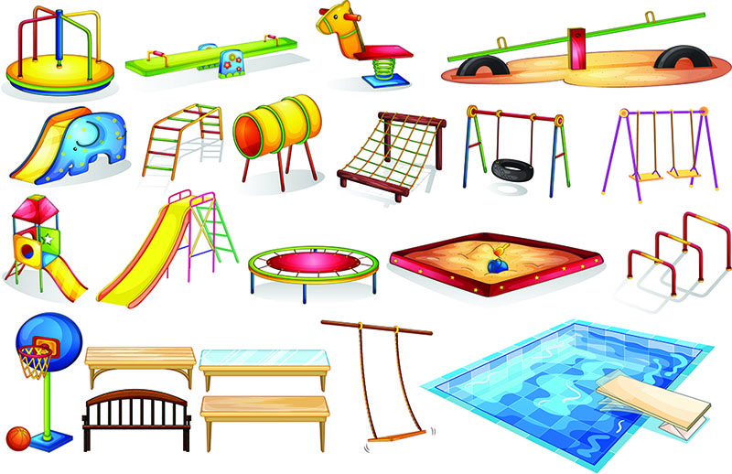

Student worksheet

3.3 Moving objects have kinetic energy

Pages 46–47 and 171

Kinetic energy

1 What is kinetic energy?

2 Which types of objects have the greatest kinetic energy?

3 Give four examples of kinetic energy.

4 Which has greater kinetic energy? Explain your answers.

a A jogger or a sprinter?

b A car moving at 100 kilometers per hour or a train moving at 100 kilometers per hour?

c Electricity or flowing water?

d A person on a bicycle moving at 5 kilometers per hour or a person on a motorcycle moving at   
60 kilometers per hour?

5 When can our eyes not detect light energy?

6 What is the function of a solar cell?

7 How is thermal energy created?

8 How/where does thermal energy move?

9 What is sound made up of?

Extend your understanding

10 Newton’s second law of motion states that force is equal to the mass of an object multiplied by its acceleration. This means that heavier objects (mass) are harder to push (force), so they cannot move as fast (acceleration). On the other hand, lighter objects are easier to push, so they can move faster.

 

a An elephant and a mouse are on skateboards. If you were to push both at the same time using the same amount of force, which one would move further? Explain your answer using Newton’s second law of motion.

Weight can also be explained using Newton’s second law of motion. Your weight (the force) is equal to your mass multiplied by your acceleration. The unit used for weight is Newtons (N).

b What is the name that is given to your acceleration (9.8 m/s/s) on Earth?

c If acceleration is constant, what it the relationship between weight and mass?

d A person has a weight of 50 N on Earth. Calculate their mass in kilograms use the equation   
*F* = *m* × *a*.

e What is the weight in Newtons of the same person on the Moon, if the Moon has th of the Earth’s acceleration?

Student worksheet

3.4 Energy can be transformed

Pages 48–49 and 171

Energy transformations

1 Name a device that will convert:

a chemical to electrical energy:

b chemical into heat energy:

c electricity to light:

d chemical energy into sound:

e electricity to heat:

f potential to kinetic energy:

g chemical energy to light:

h kinetic energy to sound:

2 Draw a flow diagram that shows all of the energy changes when:

a a light turns on

b a toaster cooks your toast

c a church bell is struck by a bell-ringer

d a firework explodes

e an iPhone is charged using energy from a coal power station

3 Why does a mug of hot chocolate eventually cool down? Where does the heat energy go?

4 What will happen to a glass of ice-cold water if left at room temperature?

5 Why does the ice-cold water form condensation on the side of the glass?

6 Does hot chocolate or cool lemonade have more thermal energy? Explain your answer

7 Which of the drinks in question 6 will have more thermal energy if they are left on the same bench overnight? Explain your answer.

Extend your understanding

In exothermic chemical reactions, reactants have more energy than products. Therefore, when the products form, the extra energy is released to the surroundings as heat.

In endothermic reactions, products have more energy than reactants. Therefore, heat must be absorbed from the surroundings for the reaction to occur.

8 If an exothermic reaction occurred in a beaker, what would the beaker feel like if you picked it up?

9 If an endothermic reaction occurred in a beaker, what would the beaker feel like if you picked it up?

10 Show the energy conversion of these two processes by drawing energy chain flow charts:

a Exothermic

b Endothermic

11 Is the burning of coal an exothermic or an endothermic reaction? Explain your answer.

Student worksheet

3.5 Energy cannot be created of destroyed

Pages 50–51 and 172

Energy efficiency

1 What is energy efficiency?

2 Why aren’t any energy conversions 100% efficient?

3 What is the law of conservation of energy?

4 Why aren’t light globes 100% energy efficient?

5 What would a 100% efficient light bulb do?

6 Complete the table below to compare the efficiency of the three different types of light globes shown:

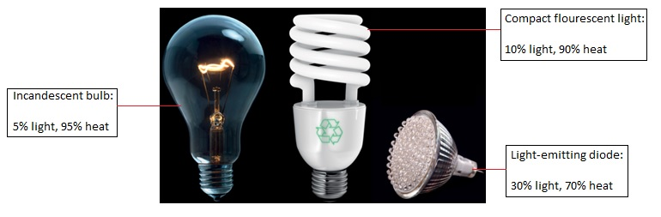

|  |  |  |  |
| --- | --- | --- | --- |
|  | Incandescent bulb | Compact fluorescent light | Light-emitting diode |
| % Light conversion |  |  |  |
| % Heat conversion |  |  |  |

7 Which of these three bulbs is the most energy efficient? Why?

8 Using the equation for energy efficiency, calculate the efficiency of each of the light bulbs:

9 Does your answer for question 7 match the calculations you completed in question 8? Why or why not?

10 Name two energy transformations that result in energy being wasted as heat and/or sound.

Extend your understanding

11 How does the law of conservation of energy relate to energy efficiency and waste energy?

12 If energy cannot be created, state three places that it comes from.

13 When energy is lost, it is usually lost as heat. What happens to the heat from light bulbs when it has been lost?

14 Why is it difficult to get this energy back once it is lost?

Student worksheet

3.6 Energy efficiency can reduce energy consumption

Pages 52–53 and 173

Minimising energy consumption

1 Explain two reasons why it is beneficial to reduce the amount of energy you use.

2 How does a hair dryer work?

3 How can you control the amount of heat and air coming out of a hair dryer?

4 Name four devices that heat either your home or your food.

5 On a cold winter night you go to watch TV in your living room and it is very cold. You put on the heater, watch your favourite show in toasty warmth, turn off the heater and then go to bed. When you wake up in the morning the room is freezing cold again. Why is this? Where does the heat go?

6 Name three ways you can minimise heat loss in your home and explain how each works.

7 Draw a flow diagram for the conversion of coal to heat and wind in your hair dryer

Extend your understanding

8 The following graph shows the overall energy consumption used in a typical household over the course of 24 hours, from midnight to midnight, during winter.

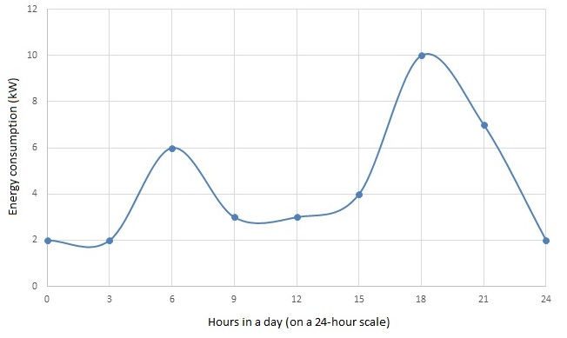

a When are there spikes in energy consumption?

b Explain why these spikes occur – what happens at this time of day?

c Suggest a possible reason why one spike is larger than the other.

d Suggest two ways that you could minimise the size of these spikes.

Student worksheet

3.7 Solar cells transform the Sun’s light energy into electrical energy

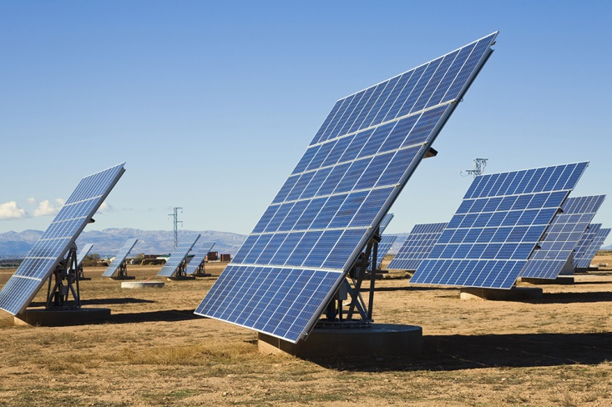Pages 54–55 and 174

Solar energy

1 What is a solar cell?

2 How is solar energy often measured?

3 The amount of solar energy is different, depending on the Australian state you live in. Which state experiences the highest and lowest solar energy? Why do you think this is?

4 What is the problem with converting light to chemical potential enegy?

5 How is this problem overcome?

6 How do solar cells work?

7 What is a photovoltaic cell?

8 How does a photovoltaic cell generate electricity?

9 How energy efficient are photovoltaic cells?

10 Why can solar cars only carry one person?

11 Why are solar cars not a practical method of transport?

Extend your understanding

12 In space, light travels at the speed of light (299 792 458 metres per second). If there is 149 597 870 700 metres between the Earth and the Sun, use the equation  to determine how many seconds it would take for the Sun’s light to reach the Earth.

13 Convert this time into minutes by dividing by 60.

14 Use the data in the following table to calculate how long it takes the Sun’s light to reach other planets in our solar system. Convert this into minutes and hours where possible.

|  |  |
| --- | --- |
| Planet | Distance from the sun (metres) |
| Mars | 227 940 000 000 |
| Jupiter | 778 330 000 000 |
| Saturn | 1 424 600 000 000 |
| Neptune | 4 501 000 000,000 |

a Sun to Mars:

b Sun to Jupiter:

c Sun to Saturn:

d Sun to Neptune:

15 Why do astronomers say that looking at stars is like looking hundreds, sometimes thousands or millions, of years into the past?

Student worksheet

3.8 Engineers use their understanding of energy to solve problems

Pages 56–57 and 175-176

Engineering

1 Explain the role of each of the following engineers. Provide examples where possible.

a Chemical engineer

b Mechanical engineer

c Electrical engineer

d Civil engineer

2 For each of the tasks below, state which type of engineer would perform this job.

a Build a bridge:

b Make a new type of biodegradable plastic:

c Build a satelite for NASA:

d Design a different type of paper:

e Design and build a car to be raced at NASCAR:

f Design and test robotics:

g Build the tallest building in the world:

h Design shatter-proof glass:

i Organise the electronics of the CERN super-collider:

j Design new medical equipment:

k Dig and reinforce a tunnel between Victoria and Tasmania:

l Build the longest waterslide in the world:

m Improve photovoltaic cells to increase energy efficiency:

3 Match each type of engineering assessment with the question it asks:

|  |  |  |
| --- | --- | --- |
| Engineering assessment |  | Question it asks |
| 1 Environmental impact |  | A What happens if it fails? |
| 2 Geotechnical hazard assessment |  | B Will it have good or bad impact on people’s lives? |
| 3 Contamination assessment |  | C What is the impact on the environment? |
| 4 Strength and facility life assessment |  | D What will happen if you dig up the soil? |
| 5 Social impact assessment |  | E Will any chemicals contaminate living things? |
| 6 Risk assessment |  | F What sort of load (or weight) can the structure withstand? |

Extend your understanding

Your best friend develops an engineering proposal to place a waterslide in your house so that it will be easier to get drinks and icy poles on hot days, and so that summer will be awesome!

The waterslide is planned to go from the kitchen at the front, through the house, and then out to the backyard.

4 As the engineering expert that you now are, evaluate your friend’s proposal (completely impartially of course) by completing the following assessments:

a Environmental impact (i.e. the impact on the rest of the house if the waterslide runs through the house)

b Social impact (i.e. will the family be happy?)

c Risk assessment

d Contamination assessment

e Strength and facility assessment

f Geotechnical hazard assessment (think about the floors)

5 What is your final assessment of the waterslide proposal? Should the project go ahead? Why or why not?